CREATE JAVA APPLICATION

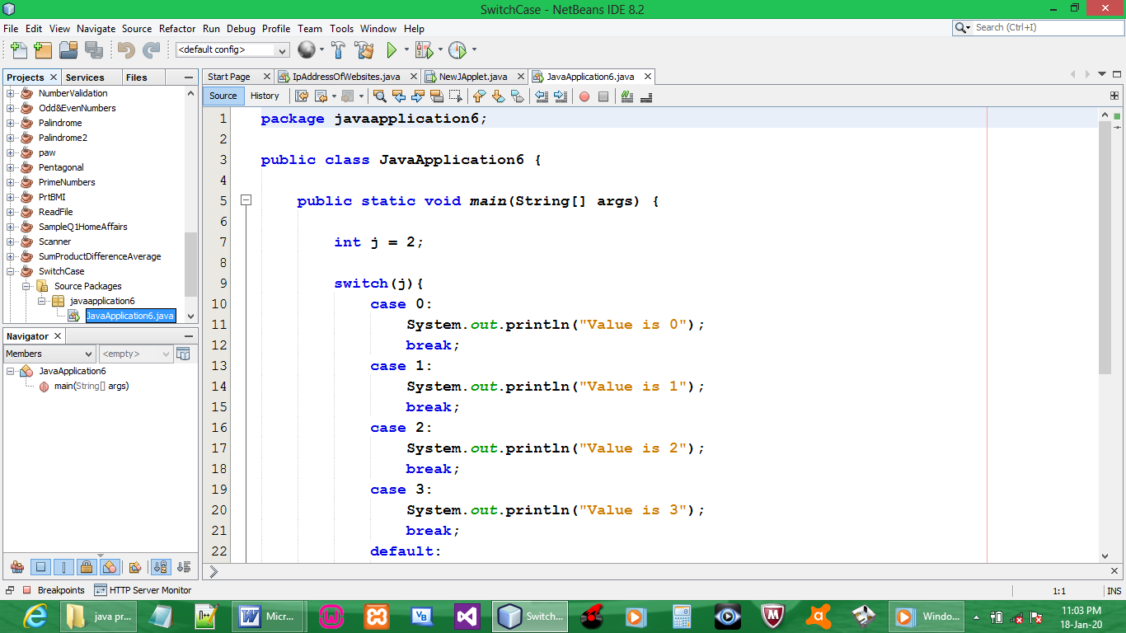

CODE:

package javaapplication6;

public class JavaApplication6 {

public static void main(String[] args) {

int j = 2;

switch(j){
case 0:
System.out.println("Value is 0");
break;
case 1:
System.out.println("Value is 1");
break;
case 2:
System.out.println("Value is 2");
break;
case 3:
System.out.println("Value is 3");
break;
default:
System.out.println("No Value");
break;
}

}

}

OUTPUT:

